Dreams, hallucinations and horror in the work of Jani Christou (1926 - 1970)
Varvara GYRA

Article published in French in the collective work The fantastic in the music of the XXth and XXIst centuries. Current music, contemporary music and film scores [Le fantastique dans les musiques des XXe et XXIe siècles. Musiques actuelles, musique contemporaine et musique de film], under the direction of Cécile Carayol, Pierre Albert Castanet and Pascal Pistone, Editions Delatour France, 2017, Pensée Musicale Collection, pp. 120-130.
Jani Christou is an emblematic figure in Hellenic musical history. He created multidisciplinary works which fall within the artistic approach of the second half of the XXth century. This composer, who was born in Cairo in 1926, drew his inspiration from Greek and Egyptian cultures, while at the same time immersing himself in the Western ideas reflected in his work and thinking. His compositions form a mysterious imaginary universe where the listener is lead to ponder on the problem of human existence and whose character in artistic performance prompts the musician to break free from inherited aesthetic norms and to exceed his own limits. They are distinguished by image-laden, graphical notation which suggests the abandon of a purely musical writing style and which includes symbols of horror, panic-stricken faces and fantasy objects and figures from the composer's dreams.
It is therefore interesting to study the place which the fantasy elements occupy in his compositions and the form in which they appear, while concentrating on the technical and psychological means which Christou uses to express horror, disquiet and anxiety. It is also useful to map the correlation between his preoccupations and his musical experiments pertaining to dreams, hallucinations and horror by looking more closely at some of his theoretical writing, notably that which concerns the concept of protoperformance. Among his work, two compositions lend themselves particularly well to this type of study: Mysterion (1966) and The Strychnine Lady (1967).
The scenic oratorio Mysterion, Christou's seminal work, for a large orchestra, triple choir, actors, five percussionists and cassette tape recording reflects the importance of the concept of transformation in the composition process. In his text A Credo for Music, the composer declares that he is "concerned with the transformation of acoustical energies into music". A musical work which is unable to provoke a transformation does not respond to his own criteria: "Absence of transforming powers keeps the acoustical events on one level, thus catering only to our sense of decoration. Art which does not rise above this level may be craftful, but is no longer meaningful." Indeed, Christou finds greater interest in art of a liberating nature, refusing decoration and considering that it does not have its place in a real musical work.
Mysterion adheres to the structure of this quest for transformation. Composed from the Book of the Dead of the Ancient Egyptians which dates to the XIIIth century BCE, this book incorporates beliefs more than seven thousand years old and gives to those who have been initiated directions about how to behave in the kingdom of the dead. It also contains precise indications regarding funerary rites which should be carried out to ensure eternal life to the dead and describes how to bring the dead back to life.
The composer designates this work as being "a re-actualisation (in the form of a concert) of a nine-degree mystery included in the eighth division of the lower world through which Afu-Ra, the Sun god, travels during the eighth hour of the night". Christou identifies Mysterion as being in the form of a dream in nine stages and specifies that "that which occurs in the centre is a nightmare". The nine Latin figures give their name to each degree and represent each section of the work. The musical form is therefore not regulated by the rules of musical order, but by rules of a literary order, which follow the specific structure of the Book of the Dead of the Ancient Egyptians.

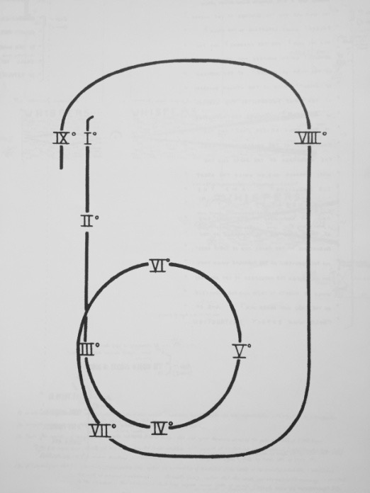

Mysterion (1966) in the form of a dream

The work was composed between 1965 and 1966 but was truly born on 28th July 1962 when the composer dreamed of a situation and a scene setting close to that of the Book of the Dead, of whose existence he was at that time unaware. Re-reading his notes about his dreams in October 1965, he was himself struck by this similarity. Indeed, it concerns a dream where he and his family have to carry out a death ritual for his brother Evey (who died in a car accident) so that his ghost will not manifest above his tomb. The participants come together in a dance during which they have to hold a ribbon while crossing their hands. They then go to the tomb of the deceased where the composer reads a lamentation to him inciting him to resurrection and life, while trying - unsuccessfully - to pronounce the word "immortality". It is a dream which creates a great deal of tension and expectation, as Christou states, but which also provokes a feeling of disappointment, as his brother is definitely dead. The composer ended up reading the Book of the Dead in August 1965 and had more dreams, which were even more intense and striking, which would also contribute in turn to the development of Mysterion.
The work exclusively contains magic formulas in archaic language comprising words of power in ancient Egyptian which the soul of the deceased person must pronounce to ensure its successful passage through the twelve divisions of the underworld. It is thanks to these words that the author possesses the power to influence and transform his listener by sending him in the direction he wishes. He can lead him into a new psychological state, like the transformation which the spectator experiences through the ecstasy of ancient Greek drama. The composer evolved an analytical diagram of the words of power used in Mysterion and attributed the identity of each division of the underworld to each section of his work.
Firstly, the words of power which make up Mysterion contain the name of the door which leads to the eighth division of the underworld, the name of the division and the names of the gods who are glorified in the Book of the Dead. The musical material also contains the names of "those who destroy", the names of the circles, of their secret doors and of those who control them, as well as the name of the final door behind which the "chamber of destruction" can be found. The names of the "secret doors of Osiris" are phrases which each begin with the declaration or operating concept: "I have made my way, I know you, and I know your name". Christou also uses the term "qerret", which means "circle", as well as syllables which carry no meaning.
The sound effects used by the composer come from nature and daily life. In the second case, they are principally sounds taken from social or contemporary life which generate a certain degree of anxiety or create disturbance. We can distinguish breathing through oxygen masks, an alarm, the piercing screams of a murder, voices and sounds heard during a cocktail party (for example, glasses or the sound produced when pouring a drink), the sound of conversations, a monotonous news programme, departure and arrival announcements in an airport, traffic noise and the sound of footsteps.
Jani Christou conceived his work as an initiatory, multidisciplinary performance and gave a great deal of importance to the participants' costumes and masks which he designed himself and which play an important part in the musical ritual. He was inspired by straight lines and ample shapes which cover the performer's body and face, aiming to suggest the mysticism which can be traced throughout the composition. These elements allow the performer to inhabit his or her role better so that that the spectator can enter more easily into the spirit of the composition.
During the initiatory ritual which takes place during Mysterion Christou offers a score which has a particularly graphic dimension and which resembles a series of musical events to be played, without their having any purely musical meaning. The entire composition is governed by the concept of praxis-metapraxis which the composer explains thus: "Any living art keeps generating an overall logic fed by a collectivity of characteristic actions. Whenever an action is purposefully performed to conform with the current overall logic characteristic of the art, that action is a ‘praxis’, or a purposeful and characteristic action. But whenever an action is purposefully performed so as to go beyond the current overall logic characteristic of the art, that action is a ‘metapraxis’, or a purposeful non-characteristic action." He then invites the performers to push their boundaries and to go beyond the logic of their predictable and habitual actions.
More specifically, it can be seen that the score is rich in symbols and intense action expressing horror through metapraxis. There is the example of a choir which - divided in half - takes part in an explosive passage: while the sopranos and altos are expressing their anger towards the audience by means of suffocating shouts of fury, the tenors and basses embark on aggressive action which involves hurling threats, before the altos launch into anguished pleading and the six soloists in the choir each deliver a different sequence in the names of "those who destroy".
The work often reaches heightened degrees of hysteria through generalised shouts of panic and by aggressive orders executed fortississimo. The composer indicates the word "terror" in the score in order to suggest the general idea of a passage and to bring a particularly graphic dimension to the score by using images of a panicked crowd, images of masks expressing various psychological states, knives to indicate a sudden stop, drawings symbolising destruction or violence etc. The suggested terror is dramatically portrayed by the tenor and basses who apply the concept of praxis-metapraxis. The composer invites them to perform their section with the nuance "silent fortissimo"; this indication, which could be described as paradoxical, means that the singers are not supposed to emit vocal sounds as in the conventional duties of a singer, and thereby participate in a praxis. In reality, the musicians are invited to push back the boundaries of their art and to produce a fortissimo sound not with their voice, which will remain silent, but through their participation in ferocious destruction within metapraxis. In the same vein, the pianist - who also participates in the metapraxis - violently closes the lid of the piano in a fortissimo fashion. The piano is thereby seen as being deprived of its role as a stringed instrument in order to change identity and become a percussion instrument.
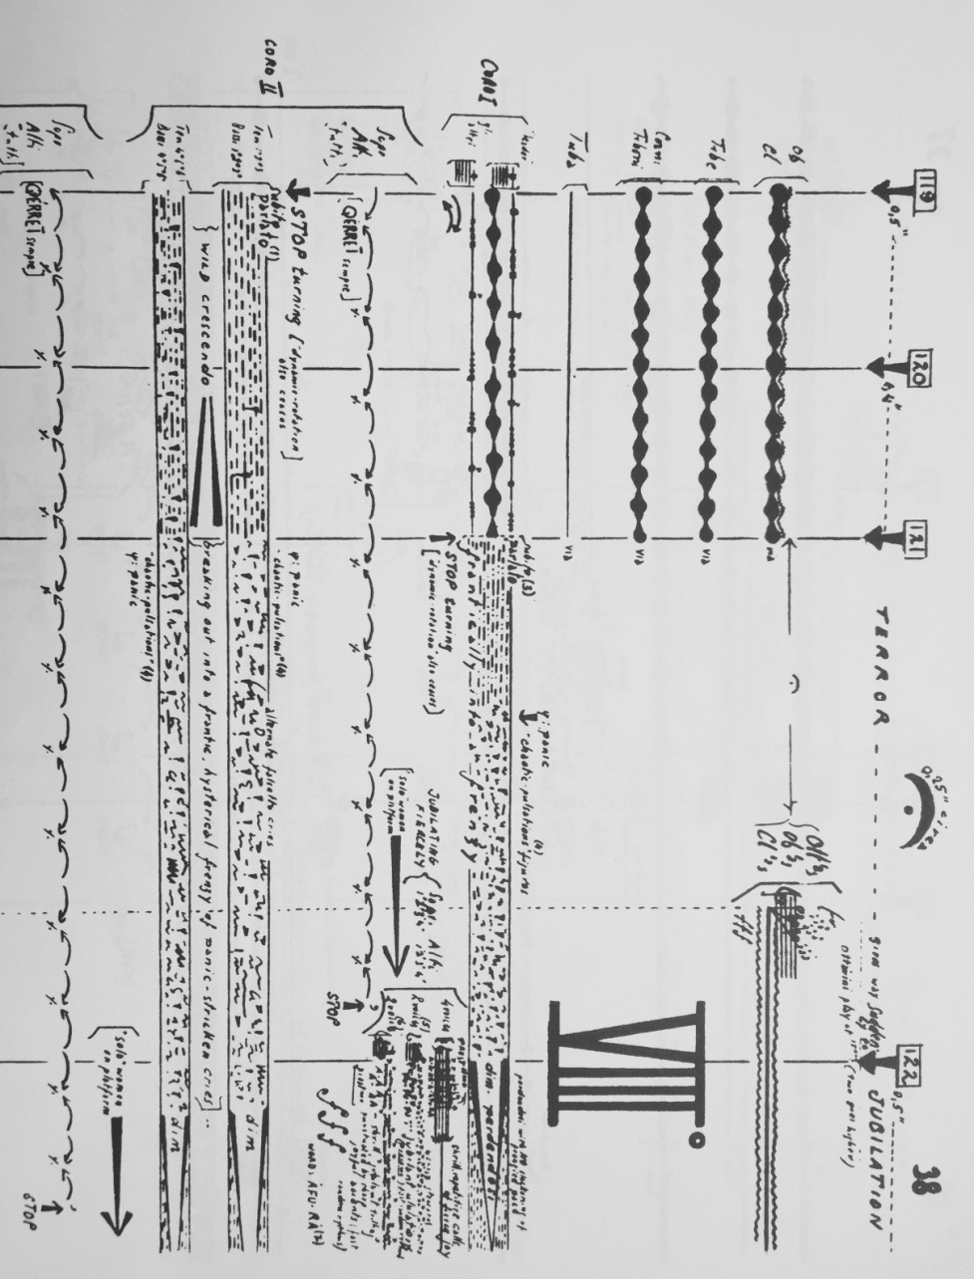
The fear provoked by the nightmarish events which occur in the bottom cycle of the diagram in nine degrees of Mysterion is represented by whistles, clapping or vocal sounds interpreted separately by each member of the choir. In this case, the composer has noted the symbol "ψ" on the score, identifying the psychological factor which occurs in the score and which suggests a psychological attitude to be adopted. The nightmare is also interpreted by groups of musicians who sing a "ψ" psychological passage, by interpreting a series of meaningless yawns, exaggerated and grotesque tremolos, shouts and bleak sounds.
Mysterion (1966), areas of duration 119-122.
The psychological and nightmarish aspect is particularly present in the composition The Strychnine Lady, dating from 1967, where the boundary between real and unreal is indefinable. Imaginary figures from a dream allude to the hallucinations caused by the use of strychnine while the composer's experiments provoke feelings of anxiety and panic in the audience. The composition draws firstly on a dream in which the composer reads a newspaper announcement about a woman who supplies strychnine and unusual experiences. The first actor reads the announcement: "I follow this up and arrangements are made for me to meet her. I am taken to a large, faceless hotel with a lot of people coming and going, the sound of music, of the shuffling of feet, an organised tour, everything is pre-arranged. ‘It had to be that way’ she said, ‘the announcement had to be startling. It had to raise wild expectations. You wouldn’t have come here otherwise’, she said, ‘you wouldn’t have come, would you?’ […]"
The second inspirational source is an extract from Psychology and Alchemy by Carl Gustav Jung which refers to the mortification of Gabricus according to the medieval alchemical text Rosarium Philosophorum. According to this text, Beya embraces Gabricus with such great love that he can absolutely no longer be seen. She absorbs him entirely into herself and divides him into indivisible parts. Merculinus thus declares: "Through themselves they are dissolved, through themselves they are put together, so that they who were two are made one, as though one body".
The work comprises musical and para-musical events such as gestures and unlikely theatrical action. The para-musical events which are produced during the work do not always coincide with the musical events. This means that the music can exist without these other events and, conversely, the events can exist without the music. Basically, there is no communication between the two. Neither is there - and this is the most important aspect for the composer - any communication between the various members within the same type of event: "It is rather like individuals caught up in a crowd; they act with the crowd but do not communicate with each other. And if there does seem to be a relationship between components of a particular group, this is because they are reacting to identical signals, not because they are establishing a relationship with each other." For example, this attitude is adopted when four actors come onto the stage to fulfil a sort of ritual taken from the domain of instrumental theatre: they come forward as though hypnotised, unwind a piece of red material using precise gestures, exchange grotesque grins and acknowledge the audience when they leave the stage.
The recitation of several fragments of a medieval alchemical text becomes a sort of re-enactment of a strange ritual which, at its culmination, requires the actors to strike wildly on a large, suspended metal sheet. The composer considers this piece as a ritual dream and states that it is a non-descriptive work which possesses elements in common with the state of mortification: "The logic here, if you can call this logic, is that of a dream in which states melt into other states with no apparent outward reason". For Christou, the ritual is a collective experience, while the dream is an individual experience. He considers that through that which is collective, however, one can reach the individual; and through that which is individual the collective can be reached. He explains: "Dreams are perhaps the means which allow us to reach that which ritual - at present obsolete- can no longer reach".
According to his text A music of confrontation the logic of the dream becomes for him a logic of composition: "If there is a logic to such a music, it is, perhaps, something like the logic at work in dreams - or nightmares - with their paradoxical counterpointing of events and their irrational fragmentations; and their obsessive repetitions, or their dark insinuations, and obscure revelations".
In Christou's universe, the dream has two principal characteristics: on the one hand, there is an informative character, given that it reflects the composer's existential worries and anxieties. This sort of anxiety is often manifest in a repetitive and insistent manner in several particularly intense forms. Let's take the example of: "a big, cylindrical, metal machine in which power is generated. This is very violent power. Suddenly there is too much power. The indicator shows the words in red: ALARM. Radiation breaks loose. All is lost. Catastrophe. There is some flooding in the streets. The lethal radiation has infected our children too. ANGUISH". On the other hand, the dream also possesses a motor characteristic as Christou, who is very sensitive to the energy generated by the dream, acts in an instinctive way and transforms an experience revealed in the dream into a musical composition. As everything is a source of psychic elements to be studied, the dream becomes a source of musical inspiration, a pretext and motivation to compose and create. It is thus that the strychnine lady who appeared in a dream finally becomes the protagonist of the eponymous work and reveals the composer's sensitivities and questioning.
In a hallucinatory context, strychnine is the means of reaching these revelations in this work. It should be highlighted here that we are in a period during which drug use was current practice in the musical world. Hashish and peyote figure among the psychedelic drugs, as well as new chemical preparations, such as "speed kill" and LSD. In this hallucinatory context, the composer gives the strychnine lady the task of reminding the dreamer thus: "You had clearly imagined the advertised poison, on a strip of glass, an infinitesimal globule of moisture" before suggesting a feeling of illusion through the speech of the three actors who also recognise their having been disappointed by the same dream which they have also had. Following this, actor n° 1 pronounces several totally meaningless phrases before concluding that it is not a negative experience. Nevertheless, he advises the audience to breathe slowly and deeply and not to panic as "there is absolutely no real cause for alarm". He specifies that his colleagues are perfectly well trained and that they have repeated each stage in the process several times, which reflects the composer's attachment to circular models, repetition and the concept of protoperformance. The actor adds that tests have demonstrated that his colleagues' saliva would stay at a normal level even during the most stressful moments and that their de-conditioning was at optimum level.
When he insists on the idea that there is nothing to worry about, the actor highlights the composer's objective: through this phrase, which constitutes a sort of power word in this work, Christou is looking to transmit a feeling of panic to the audience, given that such a feeling can be provoked through suggestion. He is able to do this either by exacerbating the worry and tension (unconscious or not) which his listeners already feel, or by deliberately causing the same symptoms provoked by the advice to not worry, which - precisely because it includes the term "worry" - justly inspires this feeling and reaches the opposite objective. In reality, if the composer's real goal was to reassure the audience, he would have used positive expressions (such as "everything's fine" or "stay calm") instead of using a term whose use appears to be innocent but which is really used to provide the opposite effect. By using these terms and means in this work, the composer is apparently alluding to the particularly tense socio-political situation in Greece during this period. The work's world première indeed took place in Athens at the beginning of April 1967, an extremely tense month socially and politically etched in Greek history as it was on 21st April 1967 that the Colonels' military coup took place, which lasted for seven years.
Being very sensitive to human evolution through history and to repetitive historical processes, in 1968 Christou wrote The Lunar Experience, where he presents his understanding of the circular pattern which reflects the terror which primitive man felt when faced with natural phenomena. Anchored in the collective unconscious, this feeling challenges the composer and forms one of the principal elements of his problems: "For countless generations the renewal of vital processes has been experienced according to a common basic pattern of ‘generation - growth - destruction - cessation’, repeated on and on. The pattern of renewal. In the depths of man's prehistory it was the moon's monthly performance that originally drew attention to this pattern. So lunar mythology suggests. So a large luminous object in a dark sky, visibly waxing and waning, and disappearing altogether - to reappear only days after, for a repeat performance - must have made a point thousands of years before man could ever have had the opportunity of recognising the pattern at work in vegetation." It is effectively from the time of Christou's first work, Phoenix music, composed in 1948, that we can see the application of this circular principle. This first composition thus ushers in the problem of renewal, which regulates the work's structure and which characterises its general conception.
Christou specifies that at first man was a hunter and it was a long time before he was able to establish agriculture, on which his survival would depend. During this time, the moon was always present and - according to the composer - it must have been of major importance in the eyes of primitive man: "There was an epoch, some time within the range of human experience, when the moon was closer to the earth that it is now. Perhaps much closer. If so, its enormous appearance must have dominated the night-sky, overwhelmingly, and its luminosity may have rivalled that of the sun itself."
Even if the moon has not supplied man with his first experience of the pattern of renewal, Christou considers that it has undoubtedly given one of his first significant experiences of this pattern. Not owing to the fact of its nocturnal setting in the sky and the darkness which follows the extinction of its light, nor in the manner in which man reacts to the mystery which is linked to something which cannot be known, neither to what can be hidden in the darkness. In his text he admits that one can easily imagine what the response of these primitive beings would have been to the moon's most spectacular manifestation, that of the eclipse: "For early man, with nothing even remotely resembling a sense of primitive astronomy, this was an irregularity and it could have caused much terror, even panic."
In this perspective of renewal associated with irregularity, according to Christou the threat of a new eclipse must have been a daunting prospect in the firmament of the growing conscious of primitive man, like the permanent threat of sudden catastrophe, and even more so as it was impossible to foresee when it would happen again. The choice of the lunar eclipse as an archetypal image of calamity in literature as in the collective conscience appears to him to be justified, as it is not possible to know at what moment the eclipse can take place. Christou often expresses his preoccupation with the fundamental image of the feeling of imminent catastrophe on a very large scale. In his personal notes he clearly recognises his fear of a catastrophe: "But I must finish my work. I must write what I have to write because everything may end… Suddenly… Just like that… The end… When least expected… And I must be prepared… In the little time left I must do what I still have to do…". The fear of imminent catastrophe does not therefore rise only from the realm of natural catastrophes, but also affects the composer's personal universe, which is so fragile and uncertain, and affects the process of musical creation.
From the viewpoint of fantasy and imagination, the study of the universe of Jani Christou through these two major works, Mysterion and The Strychnine Lady leads us to the conclusion that the composer summons up a cry of panic which looks to engage both performer and listener as well as expressing his own sensitivity to philosophical and artistic questions. As a participant in the compositional movement of the second half of the XXth century and being totally in the pursuit of freedom from the artistic heritage of the past, Christou uses the tradition of his roots and the socio-political issues of his time to express horror through his music in his own way. Through a particularly graphic score, the composer invites the artist to a performance which goes beyond the limits of conventional expression to reach metapraxis and in order to express the anxiety and tension of his time. The dream finds its place there as a starting place for compositional experience and is present in the form of a witness to the horrible events and horror which invites itself into the process of creation. While psychoanalysis brings its dimension of balance and understanding to this eventful realm, the psychological and artistic excess, which sometimes reaches the limits of hallucination and nightmare, marks the work of this XXth century Greek composer with its intensity and its spirit of urgency.

Jani CHRISTOU, "A Credo for Music", Epoches, Athens, n° 14, February 1966, p. 146 (in Greek).
Ibid.
Book of the Dead of the Ancient Egyptians, Paris, Les éditions du Cerf, 1967, p. 307. Introduction, translation, commentary by Paul Barguet.
Jani CHRISTOU, Personal handwritten notes on Mysterion drawn from the composer's archives.
Ibid.
Jani CHRISTOU, Dream, 28th-29th July 1962 (composer's personal archives).
Jani CHRISTOU, Notes on Dream, 14th-15th August 1965.
Jani CHRISTOU, Praxis and Metapraxis, notes included in the introduction to Enantiodromia (1968), London: J. & W. Chester, 1971.
"Terror", Mysterion, area of duration 121.
Cf. Jani CHRISTOU, Extract from a letter to Rhoda Lee Rhea, 10th February 1967. Available in Anna-Martine LUCCIANO, Jani Christou, The Works and Temperament of a Greek Composer, Amsterdam: Harwood Academic Press, 2000, p. 109.
Jani CHRISTOU, The Strychnine Lady, London: J. & W. Chester, 1973, figure 30.
Rosarium Philosophorum. Secunda pars alchimiae de lapide philosophico vero modo preparando, continens exactam eius scientiae progressionem. Cum figuris rei perfectionem ostendentibus, Francofurti (Frankfurt) 1550. Cf. Carl Gustav JUNG, Psychology and Alchemy, Paris: Buchet/Chastel, 1970, p. 432.
Carl Gustav JUNG, op. cit., p. 432.
Jani CHRISTOU, Thoughts, March 1967 (with no other chronological detail).
Jani CHRISTOU, The Strychnine Lady, op. cit., area of duration 45.
Jani CHRISTOU, Extract from a letter to Rhoda Lee Rhea, 10th February 1967. Available in Anna-Martine LUCCIANO, op. cit, p. 109.
Jani CHRISTOU, Thoughts, 26th September 1968.
Jani CHRISTOU, A music of confrontation. Available in Anna-Martine LUCCIANO, op. cit, p. 149-151.
Jani CHRISTOU, Dream, 15th-16th November 1964.
Cf. Jean-Pierre BOUYXOU, Pierre DELANNOY, The Hippie Adventure, Paris: Plon, 1992, p. 80.
Jani CHRISTOU, The Strychnine Lady, op. cit., area of duration 30.
Cf. Jani CHRISTOU, Protoperformance. Available in Anna-Martine LUCCIANO, op. cit., p. 146-147.
Cf. Cyril CONNOLLY, "Spare the rod and spoil the couch", The Sunday Times, London, 9th October 1966, p. 53.
Jani CHRISTOU, The Lunar Experience, 1968. Available in Anna-Martine LUCCIANO, op. cit., p. 147-149.
Ibid.
Ibid.
Darkness is an element dear to the composer, not only in a figurative way, given that he is passionate about the depth of the soul and his dark explorations, but also in its own way as he holds that light and above all darkness play an important role during the stage presentation of his works.
Ibid.
Jani CHRISTOU, Dream, Athens, 1st-2nd January 1966.

